To create scatter circle marker

from bokeh.plotting import figure as fig

from bokeh.plotting import output_file as ON

from bokeh.plotting import show

# output to the notebook

ON("ak.html")

# creating figure

plot1 = fig(plot_width = 500, plot_height = 500, title = "Scatter Markers")

# adding a circle renderer with size, color and alpha

plot1.circle([1, 2, 3, 4, 5, 6], [2, 1, 6, 8, 0],

size = 12, color = "green", alpha = 1)

# show the results

show(plot1)

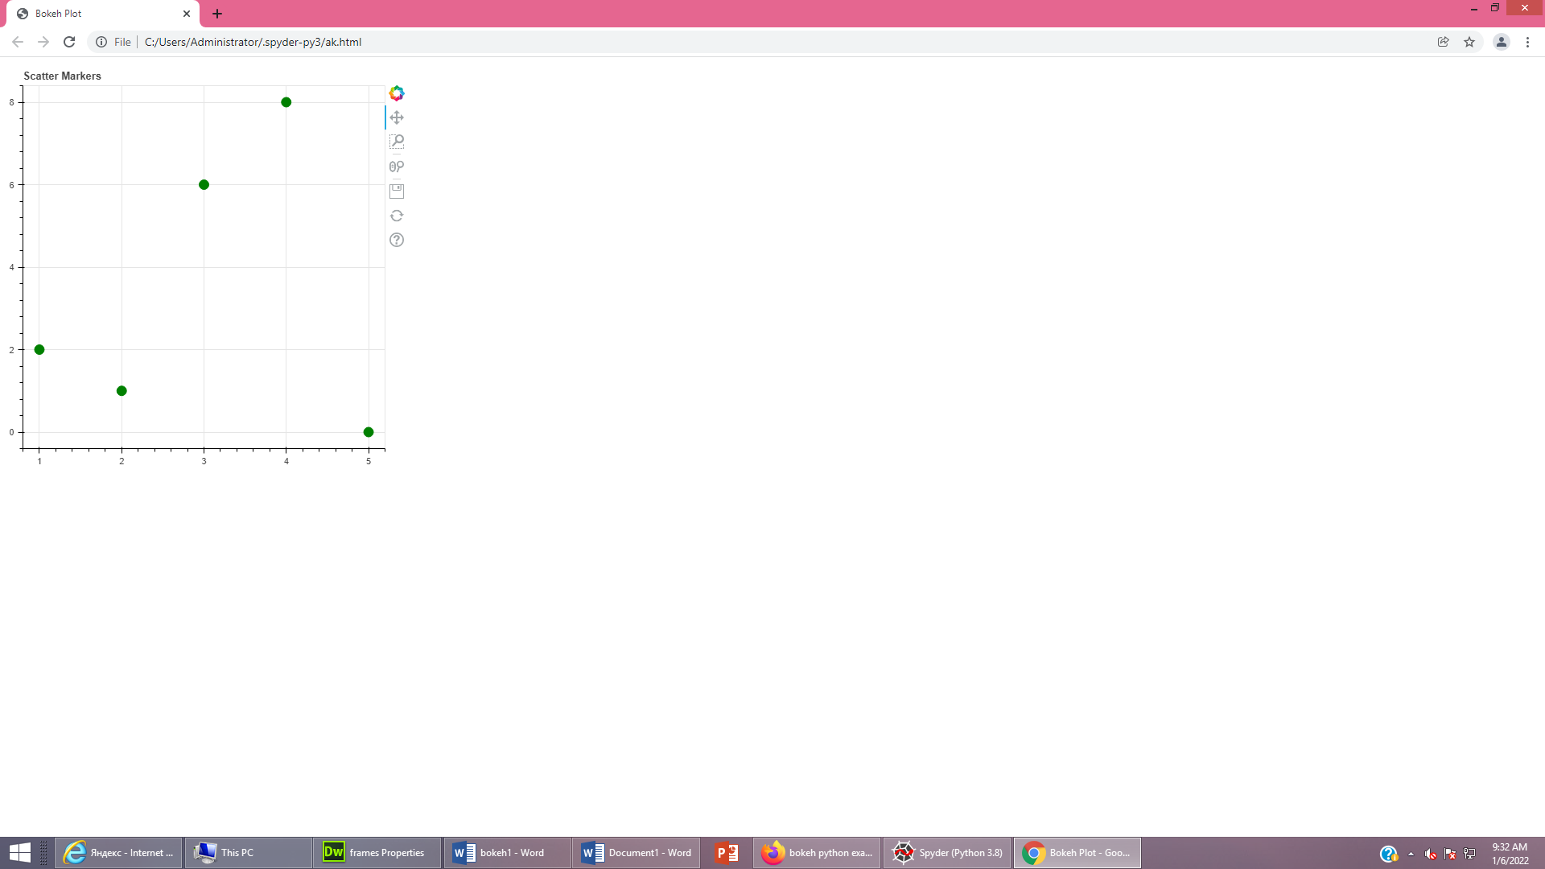

To Create a Single Line

from bokeh.plotting import figure

from bokeh.plotting import output_file

from bokeh.plotting import show

output_file("ask.html")

plot1=figure(plot_width=500,plot_height=500,title="scatter markers")

plot1.line([1,2,3,4,5,6],[2,1,6,8,0],line_width=55,color="black")

show(plot1)

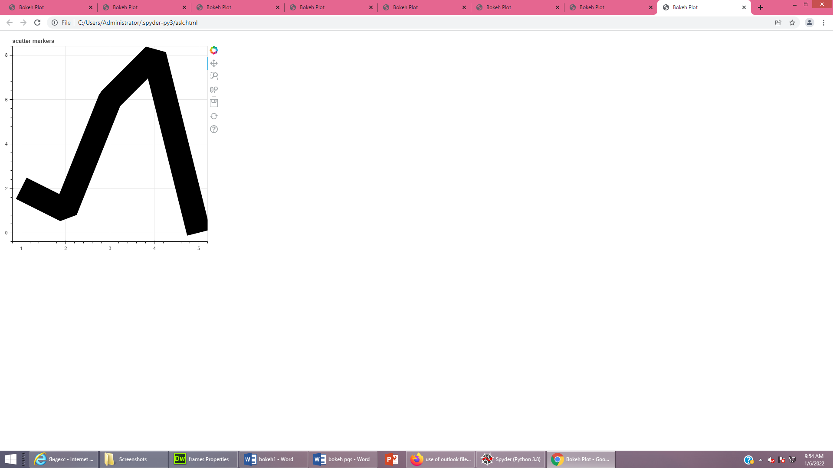

from bokeh.plotting import figure,output_file,show

output_file("awe.html")

p=figure(width=400,height=400)

p.square([1,2,3,4,5],[6,7,2,4,5],size=20,color="yellow",alpha=0.5)

show(p)

